Project title: Unraveling the role of the human orbitofrontal cortex and hippocampus in generalization
Applicant: Dr. Qingfang Liu, NIDA IRP
Main mentor: Dr. Thorsten Kahnt, NIDA IRP
Dr. Geoffrey Schoenbaum, NIDA IRP
Dr. Angela Langdon, NIMH IRP

Progress Report (1 page max)
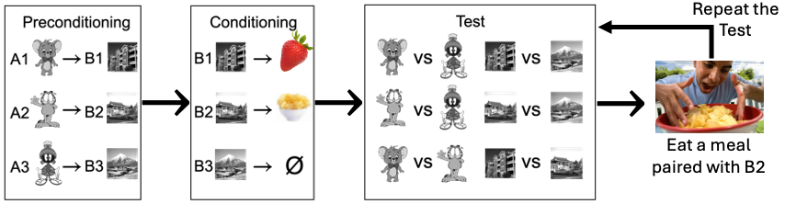
Objective: The goal of this research is to elucidate the roles of the orbitofrontal cortex (OFC) and hippocampus (HPC) in outcome-specific generalization, a critical process for adaptive decision-making. The project focuses on two aims: (1) Identify neural correlates of outcome-specific generalization using functional magnetic resonance imaging (fMRI) in healthy human subjects performing a Sensory PreConditioning and Devaluation (SPCD) task. (2) Establish the causal roles of the OFC and HPC in generalization by applying network-targeted transcranial magnetic stimulation (TMS) to modulate activity in these brain regions and assess their distinct contributions at different stages of the learning and decision-making. This work addresses fundamental neural mechanisms underpinning generalization, with implications for understanding and treating compulsive and addictive behaviors.
Fig. 1. The Sensory PreConditioning and Devaluation (SPCD) task. Hungry human participants learned associations between pre-conditioned stimuli (A, characters), conditioned stimuli (B, places), and rewards (food odors). After initial choices, selective satiation reduced preference for one odor. Participants then repeated the test to assess satiation effects on making choices.
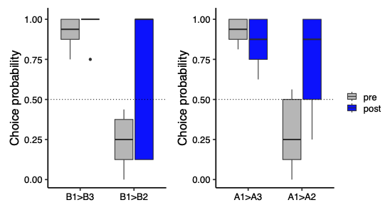
Progress summary: I have made significant progress on Aim 1, revising the experimental design to replace the original arbitrary visual symbols with place and cartoon character stimuli (Fig. 1). This change increases the likelihood of meeting the learning criterion and facilitates MRI data analysis in visual areas known to support object recognition. The behavioral pilot phase has been completed, revealing expected trends (Fig. 2). Before the meal, participants preferred conditioned stimuli associated with food odors, with a similar pattern for pre-conditioned stimuli, indicating inference of general value. After the meal, preferences shifted toward stimuli predicting the non-sated odor, reflecting the devaluation effect and suggesting inference of specific outcomes. While formal statistical analysis is limited by the small sample size, the results strongly support the effectiveness of the experimental design.
Project timeline: Since October 2024, I have collected MRI data from nine participants, and I aim to complete 30 datasets by March-April 2025. Following this, I will focus on data analysis and manuscript preparation. I also plan to present this work at SfN 2025 in San Diego, the NIDA research fellow lunch, and the CCB annual retreat later this year. Data collection for Aim 2 is scheduled to begin in October 2025.
Fig. 2. Behavioral choices from pilot phase (n = 5). "Pre" and "Post" indicate choices made before and after the meal, respectively. B refers to conditioned stimuli and A to pre-conditioned stimuli. B1 > B3 and A1 > A3 reflect value-driven choices, while B1 > B2 and A1 > A2 reflect choices requiring knowledge of the outcome-specific rewards associated with the stimuli.

Presentations
2024 CCB Annual Retreat “Roles of the human orbitofrontal cortex and hippocampus in inference-based decision-making”

